Tuncurry Great Lakes College Campus
Marine Science Snorkelling Logbook
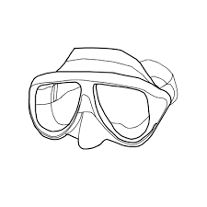

Year 9 2015
Name: _________________________

Date: _______________________________Dive No: ______________________________________
Place: _____________________________________________________________________________
Buddy: ____________________________________________________________________________
Time in Water: _________________________ Time out of Water: ____________________________
Duration of Dive: ____________________________________________________________________
Tide Details: _______________________________________________________________________
Visibility: ___________________________ Water Speed: ___________________________________
Maximum Depth: ________________________Water temp: ________________________________
Wildlife Encountered: _______________________________________________________________
__________________________________________________________________________________________________________________________________________________________________________________________________________________________________________________________________________________________________________________________________________________________________________________________________________________________________________________________________________________________________________________________________________________________________________________________________________________________________________________________________________________________________________________________________________________________________
Dive Details: _______________________________________________________________________ __________________________________________________________________________________________________________________________________________________________________________________________________________________________________________________________________________________________________________________________________________________________________________________________________________________________________________________________________________________________________________________________________________________________________________________________________________________________________________________________________________________________________________________________________________________________________
Dive Master(s): ___________________________________________________________
Accumulated Dive Time: ____________________________________________________

