Water Entries
There is not one good method to enter the water. The method you should choose is usually determined by a combination of the type of platform you are diving from, what you’re most comfortable using, and the safest way determined by the conditions.
The following are four of the most common dive types:
- Wading Entry Method - The wading entry procedure is performed from a beach or the shore. It involves wading out to your dive site by walking backwards while shuffling your feet to avoid stepping on sharp rocks.
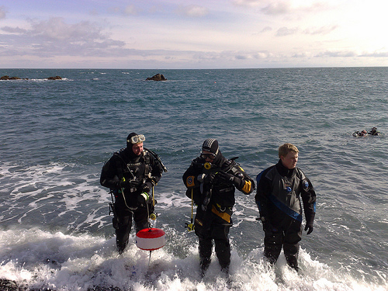
- Giant Stride Entry - Most commonly used while diving off a dive boat/jetty. Whilst standing on the edge of the dive platform holding your mask in place with your fingers, step off the platform with a giant stride forward. Scissor kick legs together as soon as you hit the water to propel yourself upwards.
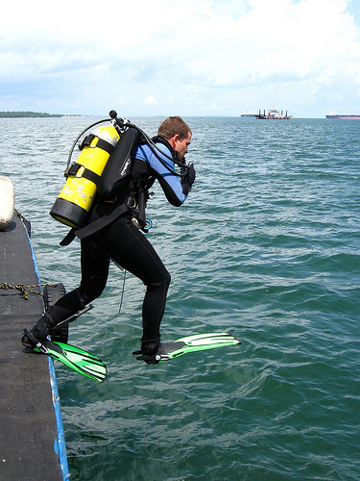
- Seated Entry – generally used when the water is too shallow for a giant stride to be completed. It involves getting kitted up in the boat or on the platform and placing both hands on side of you and then lifting yourself up and lowering yourself into the water.
- Back Roll – this is the preferred method for entering the water from a small boat as fully kitted divers standing up in a small craft could easily upset the balance of the boat. Divers should be fully outfitted and seated at the edge of the gunwale of the boat facing inwards with tank facing the water. Then with the chin tucked in and one hand holding the mask and regulator in place, the diver rolls backward moving through a full somersault into the water.
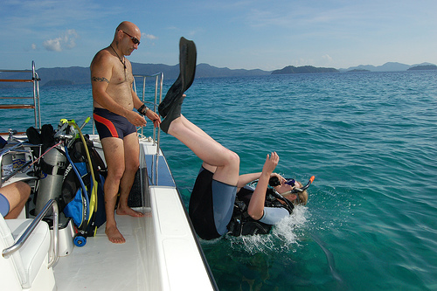

Task: Using the above information, construct a table like the one below – including: name of entry method; description of method; and diagram of method (you can use the pictures included – but must hand write the notes).

Table dimensions 5 x rows, 3 x columns.
Name of Entry | Description of entry | Diagram of entry

