AQUINAS CATHOLIC COLLEGE
MENAI
YEAR 11
MARINE STUDIES
Assessment Task Name: Marine pollution
Nature of Task: Research
Date Issued: Tuesday 14th February 2017
Due Date: Wednesday 5th April (week.10) 2017 Weighting: 20%

Task Directions

A basic introduction into marine pollution and its impact to marine environments and humans, providing the knowledge and skills to complete this course.

Outcomes to be assessed
- 1.3 recalls aspects of the maritime environment using relevant conventions, terminology and symbols learned throughout the course
- Aboriginal and Torres Strait Islander values and attitudes toward the sea
- 2.4 demonstrates knowledge and understanding of the wide variety and range of living things
- 2.5 demonstrates knowledge and understanding of the range of habitats of living things and the adaptations evident across species
- 3.3 demonstrates and generates information from data by calculating, inferring, interpreting and generalising
- 3.4 carries out planned research activities using appropriate measurements, observations, classification and recording skill.

RESEARCH PROJECT
MARINE POLLUTION

An environmental protection agency has contracted your Marketing Company to develop a Communications Plan that promotes & markets new operational sections known as Pollution Solutions.

Pollution Sollutions is responsible for investigating & monitoring the different types of marine pollutants and providing business with solutions & suggestions on how to minimise or prevent the impacts from pollution.

Prepare a communication plan to conduct research on the types of marine pollution, their impacts and management.

Types of Pollution | Major Impacts | How wide spread are the impacts? | What could or should be done to minimize these impacts?
Plastic bags | Plastic bags account for 10% of the ocean’s pollution from humans | Plastic bags present a world wide problem in our oceans | Reduce the availability of plastic bags.  $ per/plastic bag.

This unit of work has been designed to introduce students to Marine pollution and the impact to the Marine environment and humans. Complete any of the given tasks listed in the table. You must have a minimum of 12 points.

Communication tools and tactics are going to be the vehicles that your team uses to deliver your key messages to your identified Market Stakeholders. Your communication plan needs to contain examples of the following tools/tactics.

Component | Knowledge | Understanding | Applying | Analysing | Creating | Evaluating
 | 4 point |  | 6 point | 2 points
Verbal  Computing | Present a power point presentation  This will highlight the many different types of pollution and threats to the marine environment. It should also highlight how people & organisations can minimise or prevent each type of pollution.
Writing  Computing | A Logo, slogan and mission statement  This needs to capture the ideals of Pollution Solutions. |  |  | Children’s illustration storybook.  A storybook for 4 – 6 years olds about caring for the environment.  Include written text and illustrations.
Logical |  |  | Solutions Brochure  A brochure or flyer for distribution within the local community about marine pollution and what they can do to protect the reef.
Visual |  |  | Video  A video from the local area on Marine pollution solutions | Community Information Poster  This display is to highlight the types of marine pollution & the negative impacts that they have. The poster should also encourage people to use best environmental practices.
Inter  personal |  |  |  | Formulate a set of flash cards  On marine pollution & provide a  Impact statement (caused by the pollution) on the flip side.  Studyblue - flash cards
Peer Feedforward/Feedup and Feedback

78963 Marking Criteria

Component Activity | Cumulated points | Mark | Comment
Knowledge & Understanding |  | /25 | Verbal Computing
 |  |  | writing computing
Applying |  | /25 | logical
Analysing  Creating  Evaluating |  |  | Writing Computing
 |  |  | Logical
 |  |  | Visual
 |  |  | interpersonal
Presentation of work | /25
Total Marks | / 100 |  | Date: Teacher: D. Ritchie  Verification of teacher:

Websites that may contain useful research information:

- www.gbrmpa.gov.au

- www.ausmepa.org.au

- www.deh.gov.au/coast/pollution

- www.amcs.org.au

- www.amcs.org.au

- www.mesa.com.au

SAMPLE RESPONSES

Present a power point presentation
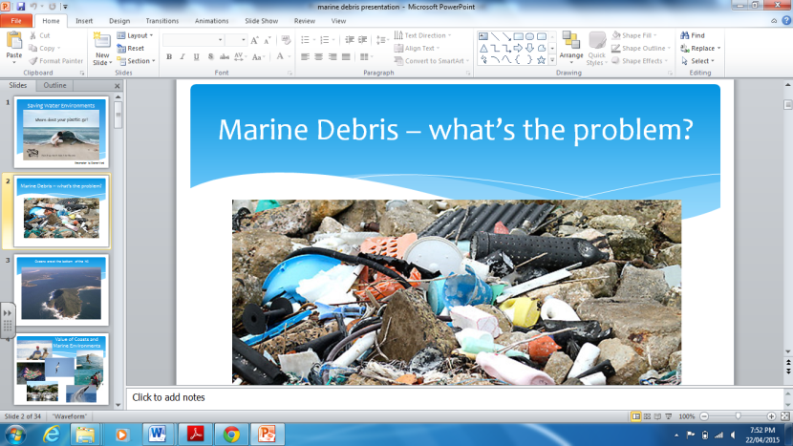

This will highlight the many different types of pollution and threats to the marine environment. It should also highlight how people & organisations can minimise or prevent each type of pollution.

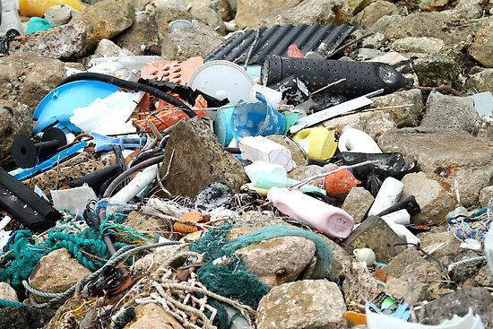

A Logo, slogan and mission statement
This needs to capture the ideals of Pollution Solutions.
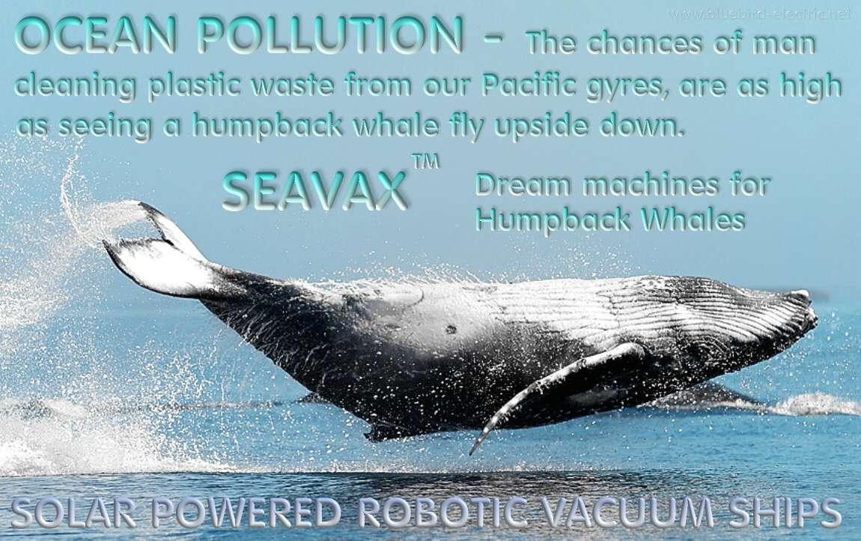

Solutions Brochure

A brochure or flyer for distribution within the local community about marine pollution and what they can do to protect the reef.

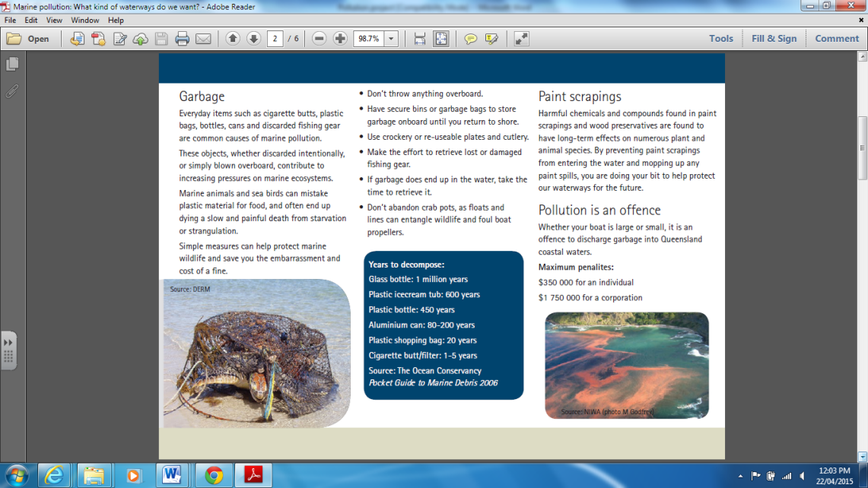
Note: Microsoft Publisher has templates you can use to complete this task.

Children’s illustration storybook.

A storybook for 4 – 6 years olds about caring for the environment.
Include written text and illustrations.

Page.1
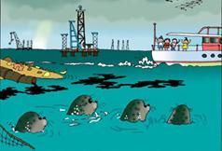
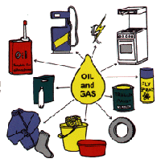
Oh no…there’re going to throw their rubbish in our home.

Page.2
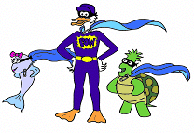
We need to ring Captain Clean up and his super hero friends!

Community Information Poster

This display is to highlight the types of marine pollution & the negative impacts that they have. The poster should also encourage people to use best environmental practices.
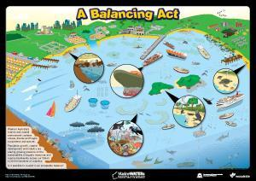

Formulate a set of flash cards
On marine pollution & provide a
Impact statement (caused by the pollution) on the flip side.

Flash cards: x 6

Side.1 Question
Side.2 Answer

